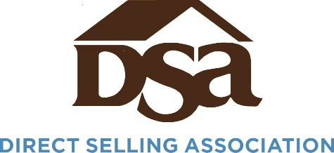
2021 FTC Engagement Timeline
April
The FTC works with Members of Congress to introduce H.R. 2668, which would provide the Commission authority to collect monetary damages under Section 13(b) to pre-empt a Supreme Court decision in AMG Capital Management v. Federal Trade Commission.
DSA Action: Worked to secure a change that would have shortened how far back the FTC can claim damages for. Signed multi-association letter supporting the principles of the legislation but urging more clarity would be needed for companies prior to FTC enforcement actions.
AMG Capital Management v. Federal Trade Commission decision by the United States Supreme Court ruled that the FTC does not have power under Section 13(b) to collect monetary damages in enforcement actions.
DSA Action: Filed amicus brief with the United States Chamber of Commerce and National Retail Federation supporting AMG’s position that the FTC did not have this power.
June
The FTC announces that they are undertaking a 10 year regulatory review of the Business Opportunity Rule. Commissioner Rohit Chopra issues a statement expressing support for the rule to cover “multi-level marketers.
DSA Action: Held multiple meetings with Commissioner Chopra, other Commissioners and FTC staff to discuss the rule. Launched a cross-sectional working group within DSA to start discussing strategy and approach for engagement on the rule.
November
US Chamber of Commerce initiates a campaign against the Federal Trade Commission regarding the Penalty Offense Authority letters and other FTC procedures. United States Chamber of Commerce President Suzanne Clark says “The FTC is waging war against American business, so the Chamber is fighting back.”
DSA Action: Urged the US Chamber to publicly elevate the issue and raise concerns with recent Commission actions.
Question for the Record submitted by United States Senator Mike Lee (R-UT) for FTC Commissioner nominee Alvaro Bedoya asks him to commit to reviewing all stakeholder positions in the upcoming review of the Business Opportunity Rule.
DSA Action: The question was submitted to Sen. Lee’s office by DSA.
December
A provision in the Build Back Better* bill would provide first time Civil Penalty Offense Authority** to the Federal Trade Commission for unfair and deceptive practices. Business groups have opposed the provision and said it violates the Byrd rule***, so should not be included.
DSA Action: Working with allies in the Senate and encouraged other business trade associations to express concern with the provision. We signed a letter with almost 90 other national, state and local organizations opposing the provision.
Sen. Lee introduces legislation that would grant the FTC 13(b) authority, but with sufficient guardrails as requested in the House legislation.
DSA Action: Coordinated with Senator Lee’s office on the language and supported introduction of the bill.
*The bill is being passed by “reconciliation” meaning it only needs 51 votes in the Senate and not 60. Democrats could pass the bill with no Republican support.
**As currently written, the statute only allows the FTC to bring an enforcement action if there is violation of a rule.
***Under rules of the United States Senate, policy provisions under budget bills cannot result in a major policy change.

